UTS SAFE WORK METHOD statement (SWMS)

- FACULTY/SUBJECT
Faculty/Subject title | 41013 Industrial Robotics
Subject supervisor/coordinator | Gavin Paul
SWMS prepared by | Aldorino Jonathan Gladwyn, Maksim Lovchev, Mikhail Lazarev.
- WORK ACTIVITY DESCRIPTION
Describe the work activity E.g. Operating, Handling, Using..  Include names of hazardous equipment, substances or materials used,  and any quantities and concentrations of substance(s) or reaction products. | In this task, we are required to control the UR3e robot and a Dobot Nova 2. We will be standing outside of the robot working area making sure we are not in contact with the robots when it is running. The goal of the robot would be to work as a barrista. There will be different type of drinks such as espresso, flat white, latte, or tea. The UR3e will mostly be frothing milk, pouring ice and making tea, while the Dobot Nova 2 will make most of the coffee using the coffee machine and the coffee grinder. The Robot UR3e and Dobot Nova 2 poses collision risks, especially if it operates outside predefined limits, while the robot gripper could cause injury due to its forceful operation.
- HAZARDS: Choose those hazard types that will need to have control measures in Section 4
Work Environment  - Slip/Trip/Fall hazards |  | Plant  - Noise  - Vibration  - Moving parts (Crushing,friction, cut, stab, shear hazards) |  | Chemical  - Dangerous when wet  - Corrosive steam |  | Ergonomic/Manual Handling  - Repetitive or awkward movements  - Lifting heavy objects  - Over reaching
Electrical  - Plug in equipment  - High voltage  - Exposed wiring  - Exposed conductors |  | Radiation  - Non-ionising radiation (Lasers, Microwaves, Ultraviolet light)  - Infrared |  | Biological  - Communicable diseases  - Work with food (eg coffee powder)  - Work with liquids |  | Psychosocial  - Aggressive or violent clients/students  - Working with timeframes  - Staffing issues
- CONTROLS MEASURES: Choose those that apply for hazards identified
Eliminate/Isolate/Substitute / Engineering Controls  - Remove hazard  - Restrict access  - Guarding / Barriers / Fume Cupboard / exhaust  - Ventilation  - Regular maintenance of equipment  - Redesign of workspace / workflow |  |  | Admin specific: Licenses/permits Work Methods  - Training Information or Instruction  - Licensing or certification of operators  - Test and tag electrical equipment  - Restricted access  - Regular breaks  - Task rotation  - Work in pairs |  | Emergency Response Systems  - First aid kit  - Emergency Stop button  - Remote Communication Mechanism
Other controls not listed


- PPE REQUIRED (Tick those that apply)
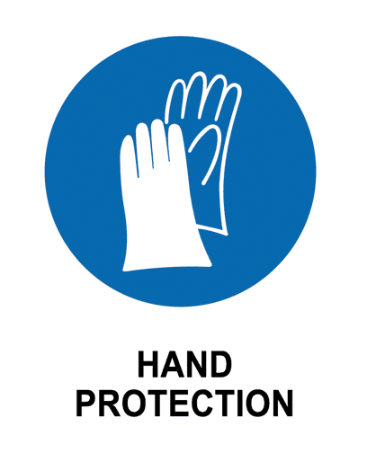

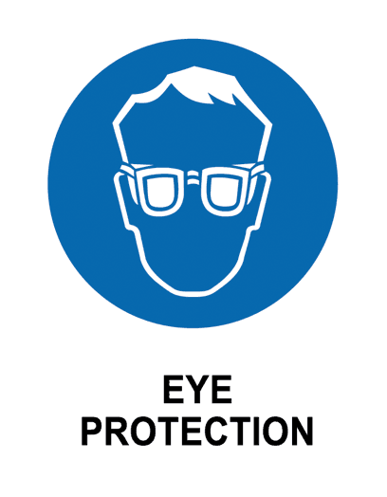
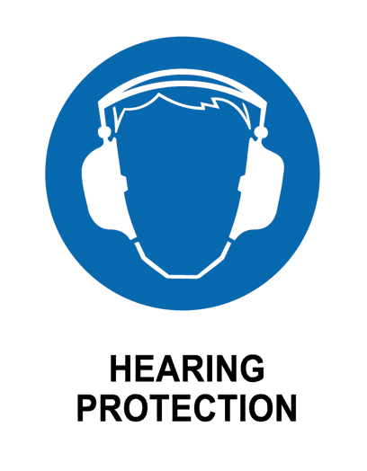
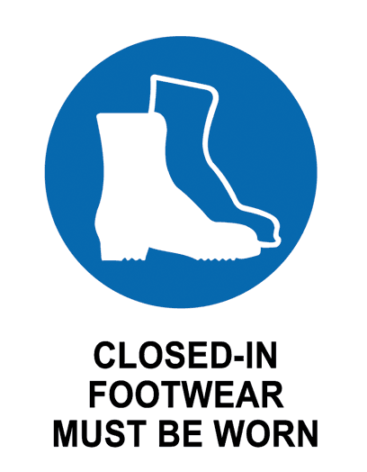
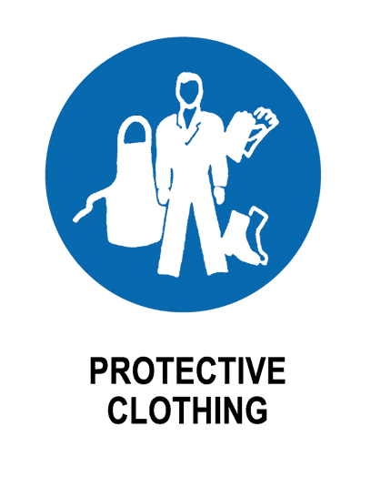




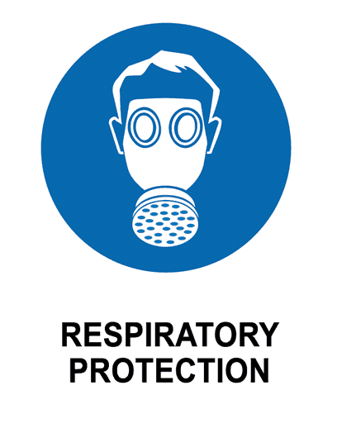
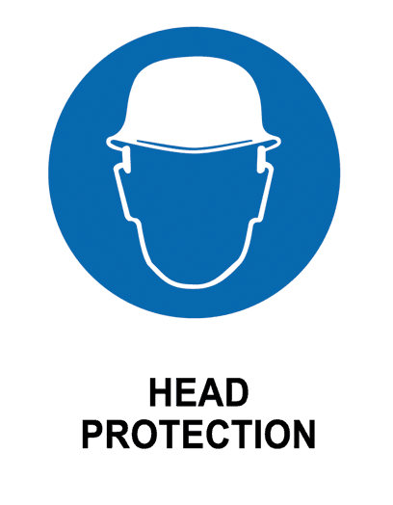


- EMERGENCY EQUIPMENT
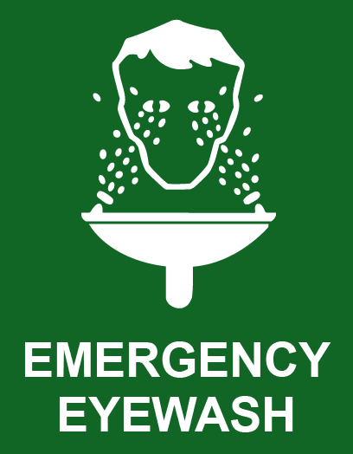
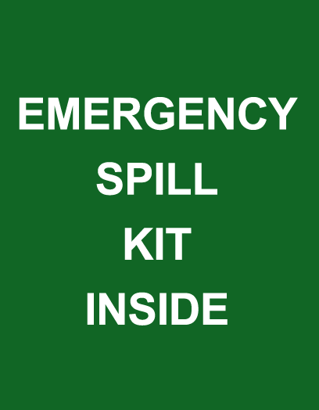
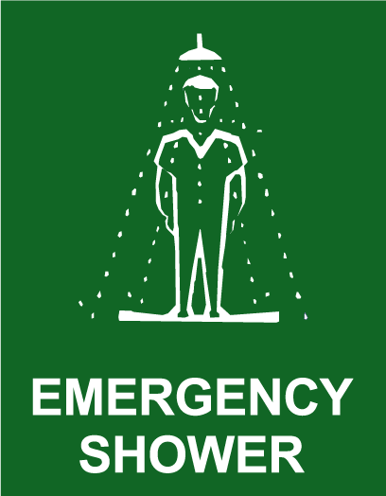



- work activity steps
before you start:

- Check the workspace if it is clear
- Verify safety equiptments are in place and functioning
- Confirm electrical connection are secure
- Review the errors in the code before using the robot
- Make sure supervisor are in the lab

steps in work activity:

- Wear safety protection
- Set up environment
- Turn on the robot
- Load and run the code to the robot
- Reset the robot from the position
- Keep a safe distance from the robot
- Adjust code
- Turn off the robot
- Clean the workspace

emergency procedures:

- Press emergency button
- Notify security or dial 6 using the UTS internal phone
- Notify lab supervisor

training required:
- Matlab Onramp certificate
- Mechatronics lab induction

- sign off
prepared by:  NAME: Aldorino jonathan gladwyn, Mikhail Lazare, Maksim lovchev | Lab Supervisor  Name: Michael Lee | Date: 09/10/2024  Review Date: 09/10/2024

